CSE590 Project 1 report

random numbers Adder

Name: Xiaobai Li
UB Person #: 50060704
Date: 3/7/2014
I. Abstract
This project is to design a circuit that generates two 5-bit random numbers and then adds them. Both the generated numbers and their addition are displayed by binary on LEDs (G1 to M5) and by decimal on 7-Segment Display of the FPGA board. The two random numbers are generated by pressing two different push-buttons: button0 is BTN0 (G12) and button1 is BTN1 (C11) of the FPGA board. The addition is controlled by a third button, button2 BTN2 (M4). Also, the switch SW0 (P11) is used to reset data.

II. Flow chart
The flow chart is shown in Fig. 1.

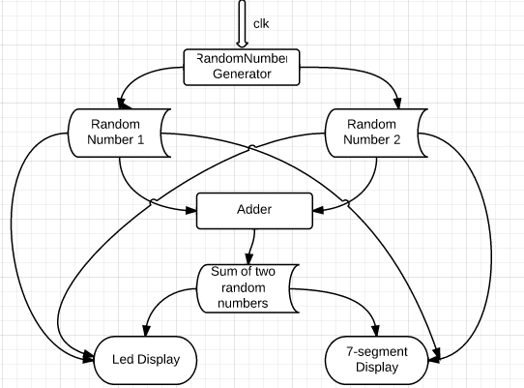

Fig.1. Flow Chart

III. Design
A. I/O design
In this project, 22 I/O are needed. They are 3 buttons, 1 switch, 7 seven-segment display LED cathodes, 6 LEDs, 4 seven-segment display LED anodes, 1 clock. I/O design in this project is listed in Table 1.

Button | btn[0] | G12 | Switch | rst | P11
Button | btn[1] | C11 | Switch | rst | P11
Button | btn[2] | M4 | Switch | rst | P11
Cathodes | cathodes[0] | L14 | Led | led[0] | M5
Cathodes | cathodes[1] | H12 | Led | led[1] | M11
Cathodes | cathodes[2] | N14 | Led | led[2] | P7
Cathodes | cathodes[3] | N11 | Led | led[3] | P6
Cathodes | cathodes[4] | P12 | Led | led[4] | N5
Cathodes | cathodes[5] | L13 | Led | led[5] | N4
Cathodes | cathodes[6] | M12 | Led
Anodes | anodes[0] | F12 | Clock | clk | B8
Anodes | anodes[1] | J12 | Clock | clk | B8
Anodes | anodes[2] | M13 | Clock
Anodes | anodes[3] | K14 | Clock

Table 1: I/O Design

B. Internal Specific Design
Module 1 - FlipFlop
module flipflop(q,d,enable,rst,clk);
input clk;
input rst;
input d,enable;
output q;
reg q;
always @(posedge clk)
begin
if (~rst)
q <= 1'b1;
else if (!enable)
q <= d;
end
endmodule
Module 2 – Generate Random Number
module RandomNumber(clk,rst,enable,state_out);
output [4:0] state_out;
input rst,enable;
input clk;
wire [4:0] state_out;

flipflop ff0 (state_out[0],feedback,enable,rst,clk);
flipflop ff1 (state_out[1],state_out[0],enable,rst,clk);
flipflop ff2 (state_out[2],state_out[1],enable,rst,clk);
flipflop ff3 (state_out[3],state_out[2],enable,rst,clk);
flipflop ff4 (state_out[4],state_out[3],enable,rst,clk);

xor G1(feedback,state_out[1],state_out[4]);

endmodule

Module 3 – Generate Binary-coded decimal
module bcd(data_in,bcd1,bcd0);

input [5:0] data_in;
output [3:0] bcd1;
output [3:0] bcd0;

reg [3:0] bcd1;
reg [3:0] bcd0;

always@ (data_in)
begin
case(data_in)
0 : begin bcd1 <= 4'b0000; bcd0 <= 4'b0000; end
1 : begin bcd1 <= 4'b0000; bcd0 <= 4'b0001; end
2 : begin bcd1 <= 4'b0000; bcd0 <= 4'b0010; end
3 : begin bcd1 <= 4'b0000; bcd0 <= 4'b0011; end
4 : begin bcd1 <= 4'b0000; bcd0 <= 4'b0100; end
5 : begin bcd1 <= 4'b0000; bcd0 <= 4'b0101; end
6 : begin bcd1 <= 4'b0000; bcd0 <= 4'b0110; end
7 : begin bcd1 <= 4'b0000; bcd0 <= 4'b0111; end
8 : begin bcd1 <= 4'b0000; bcd0 <= 4'b1000; end
9 : begin bcd1 <= 4'b0000; bcd0 <= 4'b1001; end
10 : begin bcd1 <= 4'b0001; bcd0 <= 4'b0000; end
11 : begin bcd1 <= 4'b0001; bcd0 <= 4'b0001; end
12 : begin bcd1 <= 4'b0001; bcd0 <= 4'b0010; end
13 : begin bcd1 <= 4'b0001; bcd0 <= 4'b0011; end
14 : begin bcd1 <= 4'b0001; bcd0 <= 4'b0100; end
15 : begin bcd1 <= 4'b0001; bcd0 <= 4'b0101; end
16 : begin bcd1 <= 4'b0001; bcd0 <= 4'b0110; end
17 : begin bcd1 <= 4'b0001; bcd0 <= 4'b0111; end
18 : begin bcd1 <= 4'b0001; bcd0 <= 4'b1000; end
19 : begin bcd1 <= 4'b0001; bcd0 <= 4'b1001; end
20 : begin bcd1 <= 4'b0010; bcd0 <= 4'b0000; end
21 : begin bcd1 <= 4'b0010; bcd0 <= 4'b0001; end
22 : begin bcd1 <= 4'b0010; bcd0 <= 4'b0010; end
23 : begin bcd1 <= 4'b0010; bcd0 <= 4'b0011; end
24 : begin bcd1 <= 4'b0010; bcd0 <= 4'b0100; end
25 : begin bcd1 <= 4'b0010; bcd0 <= 4'b0101; end
26 : begin bcd1 <= 4'b0010; bcd0 <= 4'b0110; end
27 : begin bcd1 <= 4'b0010; bcd0 <= 4'b0111; end
28 : begin bcd1 <= 4'b0010; bcd0 <= 4'b1000; end
29 : begin bcd1 <= 4'b0010; bcd0 <= 4'b1001; end
30 : begin bcd1 <= 4'b0011; bcd0 <= 4'b0000; end
31 : begin bcd1 <= 4'b0011; bcd0 <= 4'b0001; end
32 : begin bcd1 <= 4'b0011; bcd0 <= 4'b0010; end
33 : begin bcd1 <= 4'b0011; bcd0 <= 4'b0011; end
34 : begin bcd1 <= 4'b0011; bcd0 <= 4'b0100; end
35 : begin bcd1 <= 4'b0011; bcd0 <= 4'b0101; end
36 : begin bcd1 <= 4'b0011; bcd0 <= 4'b0110; end
37 : begin bcd1 <= 4'b0011; bcd0 <= 4'b0111; end
38 : begin bcd1 <= 4'b0011; bcd0 <= 4'b1000; end
39 : begin bcd1 <= 4'b0011; bcd0 <= 4'b1001; end
40 : begin bcd1 <= 4'b0100; bcd0 <= 4'b0000; end
41 : begin bcd1 <= 4'b0100; bcd0 <= 4'b0001; end
42 : begin bcd1 <= 4'b0100; bcd0 <= 4'b0010; end
44 : begin bcd1 <= 4'b0100; bcd0 <= 4'b0100; end
45 : begin bcd1 <= 4'b0100; bcd0 <= 4'b0101; end
46 : begin bcd1 <= 4'b0100; bcd0 <= 4'b0110; end
47 : begin bcd1 <= 4'b0100; bcd0 <= 4'b0111; end
48 : begin bcd1 <= 4'b0100; bcd0 <= 4'b1000; end
49 : begin bcd1 <= 4'b0100; bcd0 <= 4'b1001; end
50 : begin bcd1 <= 4'b0101; bcd0 <= 4'b0000; end
51 : begin bcd1 <= 4'b0101; bcd0 <= 4'b0001; end
52 : begin bcd1 <= 4'b0101; bcd0 <= 4'b0010; end
53 : begin bcd1 <= 4'b0101; bcd0 <= 4'b0011; end
54 : begin bcd1 <= 4'b0101; bcd0 <= 4'b0100; end
55 : begin bcd1 <= 4'b0101; bcd0 <= 4'b0101; end
56 : begin bcd1 <= 4'b0101; bcd0 <= 4'b0110; end
57 : begin bcd1 <= 4'b0101; bcd0 <= 4'b0111; end
58 : begin bcd1 <= 4'b0101; bcd0 <= 4'b1000; end
59 : begin bcd1 <= 4'b0101; bcd0 <= 4'b1001; end
60 : begin bcd1 <= 4'b0110; bcd0 <= 4'b0000; end
61 : begin bcd1 <= 4'b0110; bcd0 <= 4'b0001; end
62 : begin bcd1 <= 4'b0110; bcd0 <= 4'b0010; end
63 : begin bcd1 <= 4'b0110; bcd0 <= 4'b0011; end
endcase
end
endmodule

Module 4 - Seven-segment LED control
module seg_7(clk,rst,cathodes,anodes,bcd1,bcd0);

input clk,rst;
input [3:0] bcd1,bcd0;
output [6:0] cathodes;
output [3:0] anodes;
reg [6:0] cathodes;
reg [3:0] anodes;
reg [3:0] dig;
reg slow_clock;
integer count;

always @(posedge clk)
create_slow_clock(clk, slow_clock);

always @(posedge slow_clock)
begin
if (rst == 0) anodes = 4'b 1111;
else
begin
case (anodes)
4'b 1101 : anodes = 4'b 1011;
4'b 1011 : anodes = 4'b 1101;
4'b 1111 : anodes = 4'b 1011;
default : anodes = 1111;
endcase
case (anodes)
4'b 1011 : dig = bcd1;
4'b 1101 : dig = bcd0;
endcase
cathodes = calc_cathode_value(dig);
end
end

function [6:0] calc_cathode_value;
input [3:0] dig;
begin
case (dig)
0: calc_cathode_value =7'b1000000;
1: calc_cathode_value =7'b1111001;
2: calc_cathode_value =7'b0100100;
3: calc_cathode_value =7'b0110000;
4: calc_cathode_value =7'b0011001;
5: calc_cathode_value =7'b0010010;
6: calc_cathode_value =7'b0000010;
7: calc_cathode_value =7'b1111000;
8: calc_cathode_value =7'b0000000;
9: calc_cathode_value =7'b0010000;
endcase
end
endfunction

task create_slow_clock;
input clock;
inout slow_clock;
integer count;
begin
if (count > 250000)
begin
count=0;
slow_clock = ~slow_clock;
end
count = count+1;
end

endtask
endmodule

Module 5 – Top-level Module
module proj(clk,rst,btn,led,cathodes,anodes);
input clk,rst;
input [2:0] btn;
output [5:0] led;
output [6:0] cathodes;
output [3:0] anodes;

wire [4:0] rand1;
wire [4:0] rand2;
wire [3:0] bcd1,bcd0;
reg [2:0] nstate,cstate;
reg [5:0] led;
reg enable1 = 0;
reg enable2 = 0;
reg slow_clock;

always @(posedge clk or negedge rst)
begin
if (~rst) cstate <= 7;
else cstate <= nstate;
end
always @(btn or cstate)
case(btn)
3'b100: nstate=0;
3'b010: nstate=1;
3'b001: nstate=2;
3'b000: nstate = cstate;
default: nstate = 7;
endcase

always @(posedge clk)
begin
if(!rst)
begin
enable1 <= 0;
enable2 <= 0;
end
case (cstate)
0: begin
enable1 <= 1;
led = rand1;
end
1: begin
enable2 <= 1;
led = rand2;
end
2: begin
led = rand1 + rand2;
end
7: begin
led = 6'b000000;
end
endcase
end

RandomNumber RN1(clk,rst,enable1,rand1);
RandomNumber RN2(clk,rst,enable2,rand2);
bcd BCD(led,bcd1,bcd0);
seg_7 SEG7(clk,rst,cathodes,anodes,bcd1,bcd0);

endmodule

IV. Results
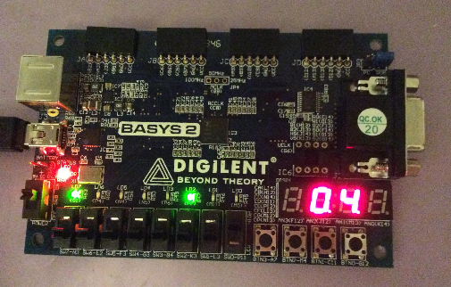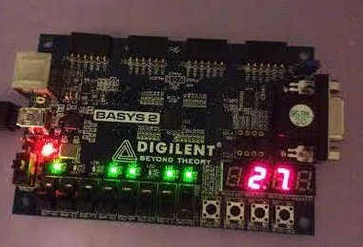
(a) Button 1 (b) Button 2
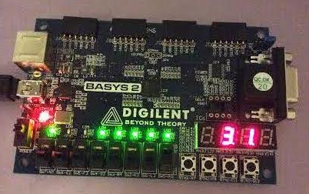
(c) Button 3

